CHAPTER 1
INTRODUCTION AND BACKGROUND
Basic Definition
Basically, there is no standard definition for smart materials, and the term smart material is generally defined as a material that can change one or more of its properties in response to an external stimulus (Harrison JS & Ounaies Z, 2001). For example, the shape of the material will change in response to different temperature or application of electrical charge or presenting of magnetic field. In general, it can be catalogued to three main groups, which are thermo-to-mechanical, electrical-to-mechanical and magnetic-to-mechanical. In the other hand, there are some materials which termed as “smart material” do not have the properties stated above, like the material with self-healing property is also termed as “smart material”. Therefore, smart material can also be expressed as a material that can perform a special action in response to some specific condition such as very high/low temperature, high stress, very high/low pH value, even material failure, etc.

Background
Materials have a strong relationship with aerospace industry, as it always determines the weight, strength, efficiency, cost and difficulty of maintenance of a machine or equipment. Therefore, the discovery of new material usually makes a breakthrough in the field of engineering and technology. Especially the findings of smart materials, it makes ground breaking changes in this field because it can provide a special function or property. Accordingly, the smart materials receive a great attention in order to improve the equipments and decrease the coast of maintenance.

History of smart materials
Actually, most of smart materials have been discovered around 50 years ago, but they were not applied to engineering field yet. As the demand of smart structures is increasing significantly, engineers started to focus on the application of smart materials to the engineering field. Accordingly, the attention of smart material has been increasing continuously since the past decade (Monner HP 2005). By now, they have been widely applied in aircrafts and other fields of technology to improve their performance. For example, a simply structured smart material actuator can replace the heavy, multi-components structured actuator according to reduce the weight and difficulty of maintenance. Moreover, the fast response in electro-to-mechanical effect of some smart material achieves an excellent result of vibration/noise control.

Significance
Studying of the smart materials is a key to make the innovations in engineering field. The reason is the conventional automatic system has several limitations comparing to the smart system. The limitations are multiple energy conversions, large number of parts, high vulnerability (especially hydraulic network) and narrower frequency bandwidth (Yousefi-Koma A & Zimcik DG, 2003). Accordingly, the conventional system has a larger weight, size and potential failure. In contrast, smart actuators, e.g. electrical-to-mechanical type, are much more efficient because the electricity is directly converse to actuation and transmitting speed of electricity is much higher. Moreover, the compact size and light weight of smart actuators will not give much loading or restriction to structure of aircraft, thus a higher freedom is given to the design equipments and control systems. Therefore, studying smart material is necessary for improving equipment and control systems performance.

REQUIREMENTS OF SMART MATERIALS
To achieve a specific objective for a particular function or application, a new material or alloy has to satisfy specific qualifications related to the following properties:-
- Technical properties, including mechanical characteristics such as plastic flow, fatigue and yield strength; and behavioral characteristics such as damage tolerance and electrical, heat and fire resistance.
- Technological properties, encompassing manufacturing, forming, welding abilities, thermal processing, waste level, workability, automation and repair capacities.
- Economic criteria, related to raw material and production costs, supply expenses and availability.
- Environmental characteristics, including features such as toxicity and pollution.
- Sustainable development criteria, implying reuse and recycling capacities.
- Functions of sensing and actuation.
1 to 5 are the properties of a general engineering material. If a general engineering material satisfies 6 property also, then it is termed as a smart material.

CHAPTER 2
TYPES OF SMART MATERIALS
Smart materials can be classified based on their origin and behavior into five main types. They are:-
- Piezoelectric Materials
- Shape Memory Alloys (SMAs)
- Optical fibers
- Magnetic Smart Materials
- Electro-strictive Ceramics.
Know, let discuss one by one respectively in-order.
1. Piezoelectric Materials
Among different types of smart material, piezoelectric material is widely used because of the fast electromechanical response, wide bandwidth, high generative force and relatively low power requirements (Harrison JS and Ounaies Z, 2001). There are two main types of piezoelectric materials are applied as smart material, which are piezoelectric ceramic and polymer. According to Harrison and Ounaies, the classic definition of piezoelectricity is the generation of electricity polarization in a material due to the mechanical stress. It is called as direct effect. Also, the piezoelectric material has a converse effect that a mechanical deformation will happen if an electrical charge or signal is applied. Accordingly, it can be a sensor to detect the mechanical stress by direct effect. Alternatively, a significant increase of size due to the electrical charge can be an actuator.
Examples: - Barium titanate (BaTiO₃)—Barium titanate was the first piezoelectric ceramic discovered. Lead titanate (PbTiO₃), Lead zirconate titanate (Pb[Zr_{x}Ti_{1−x}]O₃ 0≤x≤1)—more commonly known as PZT, lead zirconate titanate is the most common piezoelectric ceramic in use today.
Applications: - High voltage and power sources, Sensors, Actuators, Piezoelectric motors, Reduction of vibrations and noise, Infertility treatment.

2.Shape Memory Alloys
A shape-memory alloy (SMA, smart metal, memory metal, memory alloy, muscle wire, smart alloy) is an alloy that "remembers" its original, cold-forged shape: returning to the pre-deformed shape when heated. This material is a lightweight, solid-state alternative to conventional actuators such as hydraulic, pneumatic, and motor-based systems. Shape-memory alloys have applications in industries including medicine and aerospace.
Shape memory alloys (SMAs) are metallic alloys which undergo solid-to-solid transformations caused by temperature and stress changes and they can recover to their original state (Hartl and Lagoudas, 2007). The phase transformations are unique as they are attached to large recoverable strains. The strains are referred to as transformation strains and standard thermoelastic strains as well (Hartl and Lagoudas, 2007). With the ability to recover strain in the presence of stress, SMAs are defined as one kind of smart materials which are highly demanded for application in engineering industry. SMAs have higher actuation forces and displacements at low frequencies compared to other smart materials. With the application of SMAs, the complexity of a system can be reduced compared to the same system utilizing standard technology such as electromechanical or hydraulic actuator (Hartl and Lagoudas, 2007). For example, a multiple moving parts can be replaced with a single active element which can lead to higher overall reliability. Therefore, SMAs were called smart materials because they seem to be a feasible solution to very complex engineering problems especially in aerospace industry.

Examples:- The martensitic transformation can convert into two phases which are austenite and martensite. Austenite is a cubic crystalline structure exist in low temperature while martensite is a tetragonal crystalline in high temperature. The martensite transformation has three special properties:
· They are able to switch from high to low damping characteristic when
temperature or stress changes.
· Austenite has a super-elastic behavior in high temperature.
· The shape memory effect upon heating from a deformed martensitic state.

Applications:- Aircraft, Automotive, Telecommunication etc.

3. Optical fiber

An optical fiber (or optical fibre) is a flexible, transparent fiber made of glass (silica) or plastic, slightly thicker than a human hair. It functions as a waveguide, or “light pipe”, to transmit light between the two ends of the fiber. The field of applied science and engineering concerned with the design and application of optical fibers is known as fiber optics.

Optical fibers are widely used in fiber-optic communications, which permits transmission over longer distances and at higher bandwidths (data rates) than other forms of communication. Fibers are used instead of metal wires because signals travel along them with less loss and are also immune to electromagnetic interference. Fibers are also used for illumination, and are wrapped in bundles so that they may be used to carry images, thus allowing viewing in confined spaces. Specially designed fibers are used for a variety of other applications, including sensors and fiber lasers.

OPTICAL FIBER TYPES
There are 3 basic types of optical fibers: multimode graded-index fiber, multimode step-index fiber and single-mode step-index fibers.
A multimode fiber can propagate hundreds of light modes at one time while single-mode fibers only propagate one mode as shown in figure
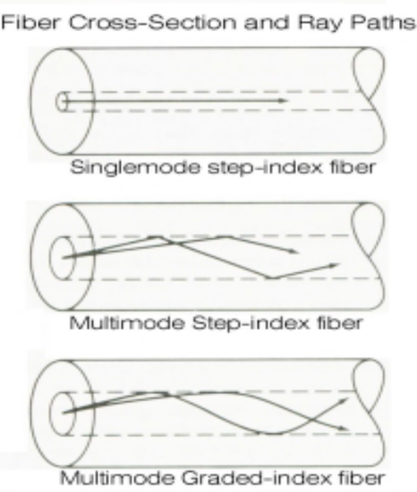
The difference between graded-index and step-index fibers is that in a graded index fiber it has a core whose refractive index varies with the distance from the fiber axis, while the step-index has core with the same refractive index throughout the fiber. Since the single-mode fibers propagate light in one clearly defined path, intermodal dispersion effects is not present, allowing the fiber to operate at larger bandwidths than a multimode fiber. On the other hand, multimode fibers have large intermodal dispersion effects due to the many light modes of propagations it handles at one time. Because of this multimode fibers operate at lower bandwidths, however they are typically used for enterprise systems such as offices, buildings, universities since they are more cost effective than single mode ones.

Application:- Optical fiber communication, Fiber optic sensors etc.

4. Magnetic Smart Materials

Magnetostriction is a dimensional change of a magnetic smart material (MSM) caused by a change in its magnetic state. Magnetostriction arises from a reorientation of the atomic magnetic moments. When the magnetic moments are completely aligned, saturation occurs after which increasing the applied magnetic field will produce no further magnetostriction. The amount of magnetostriction at saturation is the most fundamental measure of MSM material.
When subjected to a magnetic field, and vice versa (direct and converse effects), this material will undergo an induced mechanical strain. Consequently, it can be used as sensors and/or actuators. The magnetostricive material was first discovered by James P. Joule in 1840s. Iron, cobalt and nickel have the magnetostrictive effect. However, cobalt and nickel have small strains in their properties. Application of them is limited and therefore commercialization has begun to discover the giant magnetostriction rare-earth alloys during the 1960s. Terfenol-D is the alloy that has 0.2-0.7% strain higher than nickel at room temperature and relatively small applied fields (Joshi & Bent 1999).
Example: Terfenol-D
Applications:- actuator, sensor etc..

5. Electrostrictive ceramics
This material has the same properties as piezoelectric material, but the mechanical change is proportional to the square of the electric field. This characteristic will always produce displacements in the same direction.
The electrostrictive materials are important constituents of electromechanical sensors, actuators and smart structures. The electrostrictive effect can be found in all materials although it is too tiny to utilize practically. Electrostrictive ceramics is based on a class of materials called relaxor ferroelectrics and they have been used in many commercial systems nowadays (Ecertec Ltd 2000). The electrostrictive materials used to date are much more temperature-sensitive than piezoelectric ceramics. Besides, the effective use of electrostrictive actuators in smart structure systems is necessary to accurately measure the actuator strain vs. field characteristics.

CHAPTER 3
SMART SYSTEMS

Definition
Smart systems are defined as miniaturized devices that incorporate functions of sensing, actuation and control. They are capable of describing and analyzing a situation, and taking decisions based on the available data in a predictive or adaptive manner, thereby performing smart actions. In most cases the “smartness” of the system can be attributed to autonomous operation based on closed loop control, energy efficiency and networking capabilities.
A lot of smart systems evolved from microsystems. They combine technologies and components from Microsystems technology (miniaturized electric, mechanical, optical and fluidic devices) with knowledge, technology and functionality from other disciplines like biology, chemistry, nano sciences or cognitive sciences. Major application fields of smart systems are manufacturing technologies, medical technologies, automotive, aerospace, safety and security, logistics and ICT.

Requirements of Smart Systems
1. High degree of reliability, efficiency and sustainability not only of the structure but also of the whole system.
2. High security of the infrastructures particularly when subjected to extreme and unconventional conditions.
3. Full integration of all the functions of the system.
4. Continuous health and integrity monitoring.
5. Damage detection and self-recovery.
6. Intelligent operational management system.

Why smart materials technology for smart systems?
1. New sensing materials and devices.
2. New actuation materials and devices.
3. New control devices and techniques.
4. Self-detection, self-diagnostic, self-corrective and self-controlled functions of smart materials/systems.
So, the smart materials form the basic components of smart systems.

COMPONENTS OF SMART SYSTEMS
As described earlier, a smart structure is a system that incorporates particular functions of sensing and actuation to perform smart actions in an ingenious way. The basic five components of a smart structure are summarized as follows:
- Sensors for signal acquisition (Data acquisition unit)
- elements transmitting the information to the command and control unit (Data transmitting unit)
- command and control units
- components transmitting decisions and instructions(Data Instructions unit)
- actuators that perform or trigger the required action(Action Devices)
Let’s, review one by one in-detail.

1. Sensors for signal acquisition (Data acquisition unit)
Data acquisition is also called as tactile sensing. The aim of this component is to collect the required raw data needed by appropriate sensing and monitoring of the structure.
The sensing components of a smart structure are designed according to the nature of the event to be sensed — radiation, magnetic, thermal, mechanical or chemical — as well as according to the nature of the output required, such as thermal, magnetic, electrical, optical or mechanical. Other features considered are the size, geometry and mechanical properties of the required interface; the type of the environmental conditions, such as corrosion, thermal, magnetic or electrical and, finally, the operational properties of the collected data such as sensitivity, bandwidth, linearity, gauge length, range. Fiber optics are an excellent example of sensors.

2. Data Transmitting Unit
The purpose of this part is to forward the raw data to the local and/or central command and control units. It is used to transfer the data collected by the Data acquisition unit.

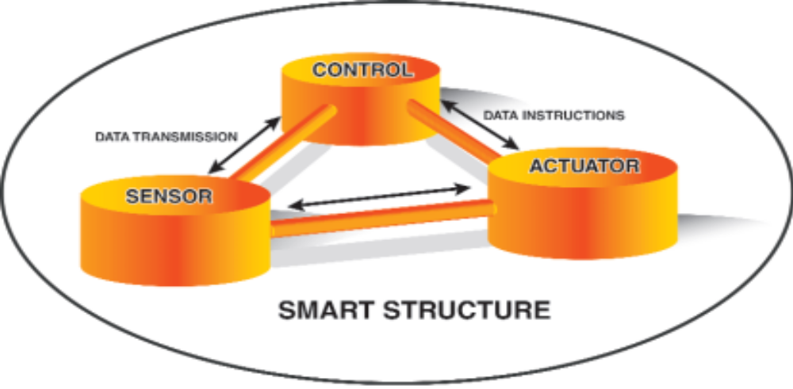

Figure: Five basic components of Smart systems
3. Command and Control Unit
The role of this unit is to manage and control the whole system by analyzing the data, reaching the appropriate conclusion, and determining the actions required.
The command and control unit is the manager of day-to-day operations, responsible for monitoring the health and integrity of the system by means of a communication network which works in real time. The unit operates by controlling a compendium of integrated non-destructive evaluation instruments, by managing optical fiber sensors and actuators, or by overseeing operational and control devices. This is the brain of the smart structure and has two basic and distinct functions:
- The Processing function
- The Analysis function
4. Data Instructions unit
The function of this part is to transmit the decisions and the associated instructions back to the members of the structure. It transmitte’s the output from the command and control unit the desired parts.
5. Action Devices
The purpose of this part is to take action by triggering the controlling devices/units. Like the sensing component, the actuating components are designed according to the nature of the required actuation — optical, magnetic, thermal, mechanical or chemical — as well as according to the nature of the driving energy, such as thermal, magnetic, electrical or chemical. Here also, environmental considerations such as thermal, magnetic or electrical properties and corrosion, as well as the size, geometry and mechanical properties of the interface have to be considered. Finally, the properties of the actuators such as displacement, force generation, hysteresis, response time and bandwidth are also specified appropriately.

If human body is considered as an ideal smart system, then a comparison of human part the respective smart system part is given in the below table:-

Component Of Smart System | Respective Human Part
Data Acquisition Unit | Hands, Legs & Eyes
Data Transmitting Unit | Sensory Nerves
Command And Control Unit | Brain
Data Instructions Unit | Sensory Nerves
Action Devices | Muscles

A FEW EXAMPLES

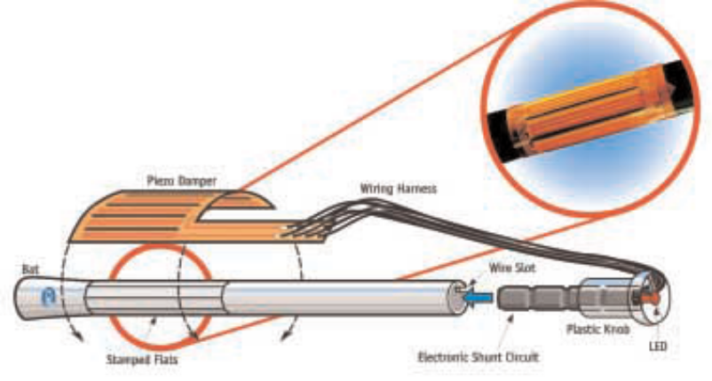
Figure: A Smart Electrical Baseball Bat
Vibration reduction in sporting goods: A new generation of tennis rackets, golf clubs, baseball bats has shown in the above Figure and ski boards have been introduced to reduce the vibration in these sporting goods, increasing the user’s comfort and reducing injuries.

Noise reduction in vehicle: Filaments of piezoelectric ceramic fiber shaped into various geometries are used in conventional fabric or material processing to counter noise in vehicles, neutralizes shaking in helicopter rotor blades, or nullify or at least diminish vibrations in air conditioner fans and automobile dashboards.

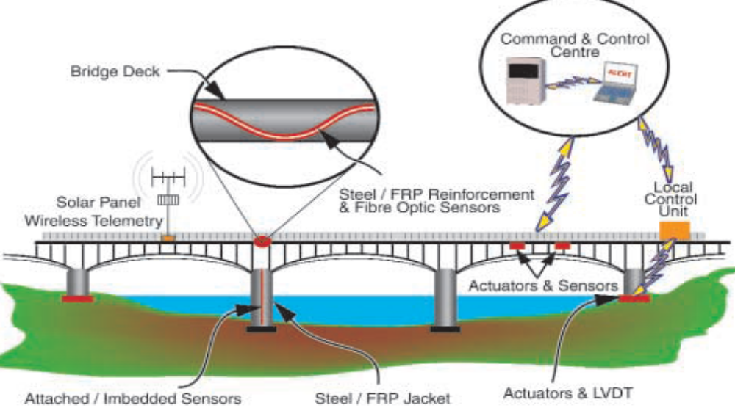

Figure: A Schematic View of a Smart Bridge

MILITARY APPLICATIONS
A number of distinctly military applications for the use of smart materials and smart systems can be delineated, among them:

Smart Skin: In battle soldiers could wear a T-shirt made of special tactile material that can detect a variety of signals from the human body, such as detection of hits by bullets. It can then signal the nature of the wound or injury, analyze their extent, decide on the urgency to react, and even takes some action to stabilize the injury.

Smart Aircraft: Smart systems can used to building better air-craft with advanced protection and control systems. Effective guidance can also be increased in the aviation industry by using smart materials and systems for controlling of air-craft.

Autonomous Smart systems: Ground, marine or space smart vehicles will be a feature of future battles. These carriage systems, whether manned or unmanned, and equipped with sensors, actuators and sophisticated controls, will improve surveillance and target identification and improve battlefield awareness.

CHAPTER 4
POTENTIAL BENEFITS & CONCLUSION

THE POTENTIAL BENEFITS
The potential future benefits of smart materials, structures and systems are amazing in their scope. This technology gives promise of optimum responses to highly complex problem areas by, for example, providing early warning of the problems or adapting the response to cope with unforeseen conditions, thus enhancing the survivability of the system and improving its life cycle. Moreover, enhancements to many products could provide better control by minimizing distortion and increasing precision.
Another possible benefit is enhanced preventative maintenance of systems and thus better performance of their functions. By its nature, the technology of smart materials and structures is a highly interdisciplinary field, encompassing the basic sciences — physics, chemistry, mechanics, computing and electronics — as well as the applied sciences and engineering such as aeronautics and mechanical engineering. This may explain the slow progress of the application of smart structures in engineering systems, even if the science of smart materials is moving very fast.

CONCLUSION
Today, the most promising technologies for lifetime efficiency and improved reliability include the use of smart materials and structures. Understanding and controlling the composition and microstructure of any new materials are the ultimate objectives of research in this field, and is crucial to the production of good smart materials. The insights gained by gathering data on the behaviour of a material’s crystal inner structure as it heats and cools, deforms and changes, will speed the development of new materials for use in different applications. Structural ceramics, superconducting wires and nanostructural materials are good examples of the complex materials that will fashion nanotechnology. New or advanced materials to reduce weight, eliminate sound, reflect more light, dampen vibration and handle more heat will lead to smart structures and systems which will definitively enhance our quality of life.

